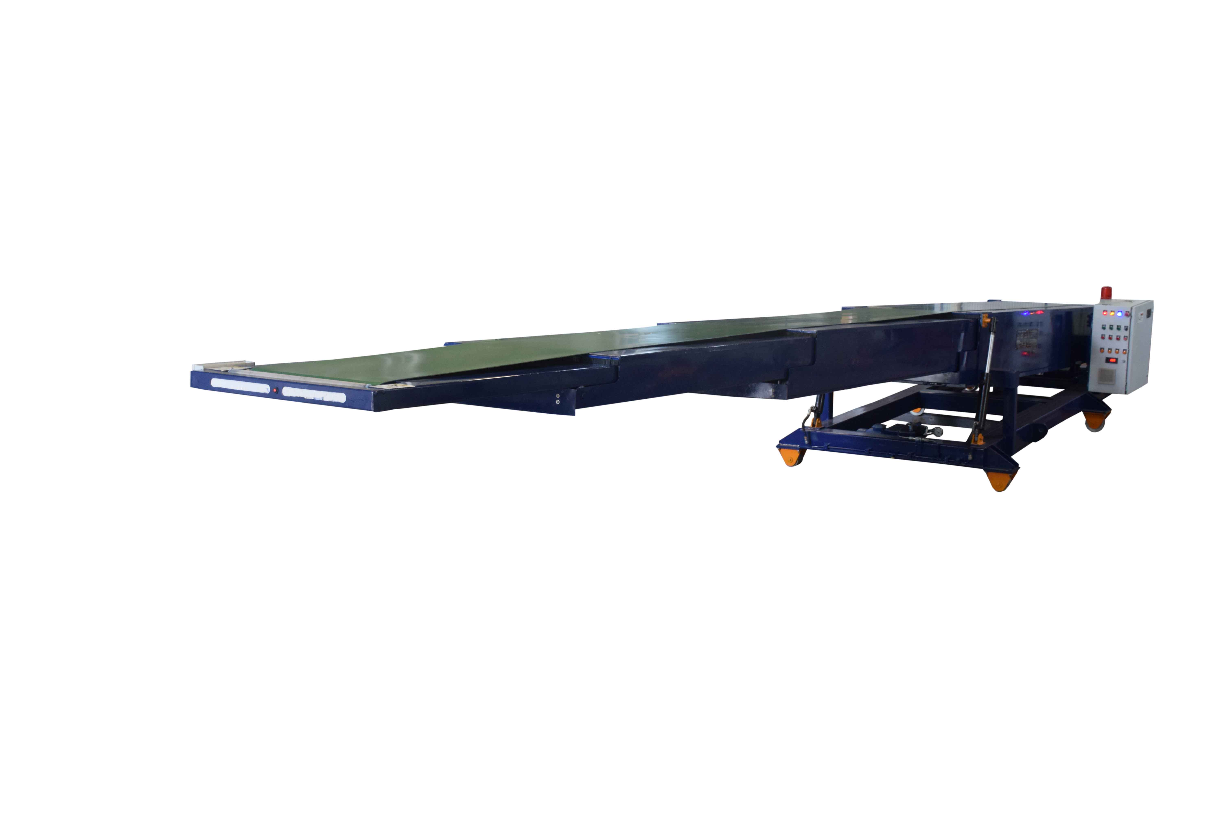NIHVA make – Telescopic Conveyor
Description | Telescopic Conveyor
Size of Conveyor | 21000 mm
Elongated length with no of boom | 14000 mm
Collapsed length | 7000 mm
Width of Belt | 650mm
Speed of Conveyor | 30 Mtr/min ( Adjustable )
- Max Speed | 32 mtr/min
- Min Speed | 15 mtr/min
Speed of Conveyor (with load)
- Max Speed | 286 RPM
- Min Speed | 160 RPM
Cycle Time (for Telescopic Operation) | 100 -150 Sec
Cycle Time (for Telescopic collapsing operation) | 100 -120 Sec
Capacity of Conveyor | 30kg/mtr
Weight of Total System | 750Kgs
Roller Guide with chain drive for telescopic operation
Brake motor used in conveyor | 4.25 hp, 2hp, 1.5hp
Motor Make | Hindustan Motor
Hydraulic Lifting arrangement for conveying height adjustment
Rigid piping of Hydraulic connections
Cable routing through Flexible conduit
Belt Tightening arrangement to avoid slagging in Belt
Led Light unit is mounted at front of boom to illuminate light in container
Audible warning to alert operator of impending belt starts
Anti-collision strip fitted at the front of the boom which causes the machine to retract / Stop
Main Supply | 415V, 20A
Control Voltage | 24V DC
Belt Speed | 15 Mtr/min
Forward & Retract Speed | 6 Mtr/min
Power Pack | 2.5 hp/ 15 ltr

